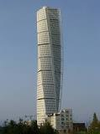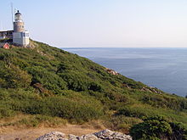
International SM meeting in Sweden, June 6-9 2014.
Dear SM friends, we hope our first invitation has reached you. This is the basic outline of the program: Participants are expected to arrive during Friday afternoon/early evening. The three evening meals will be served at Örenäs Slott where we are staying.
On Saturday we will visit the region of Malmö by coach and do some sightseeing which will partly be car related. The high point of the day will be lunch at the top floor of Northern Europe’s highest housing building, the spectacular Turning Torso.
The Sunday will be spent driving our SM-s northwards on scenic roads through the National Park Söderåsen and on to the high promontory of Kullen with its light house. We will arrive for a visit and lunch at the royal palace of Sofiero with its famous garden. The traditional Gala Dinner will be held on Sunday evening.
There will of course be more activities during our days together and we will try to plan for a pleasant time together with new and old friends. In the coming weeks an entry form will be published on club homepages and will be found on our Scandinavian site www.citroensm.no Any questions are welcome by mail to: frykholm@telia.com
SM Suède hopes to welcome you in Sweden next year! Lars Frykholm

